**SCREENSHOTS**

1. LOGIN PAGE

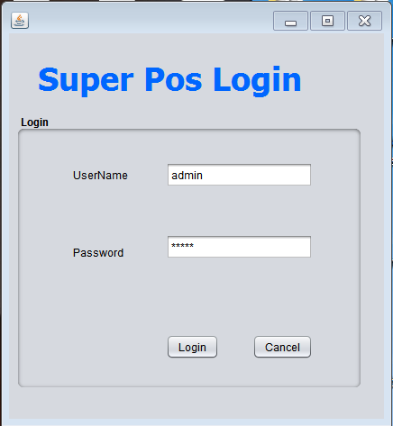  
2.POS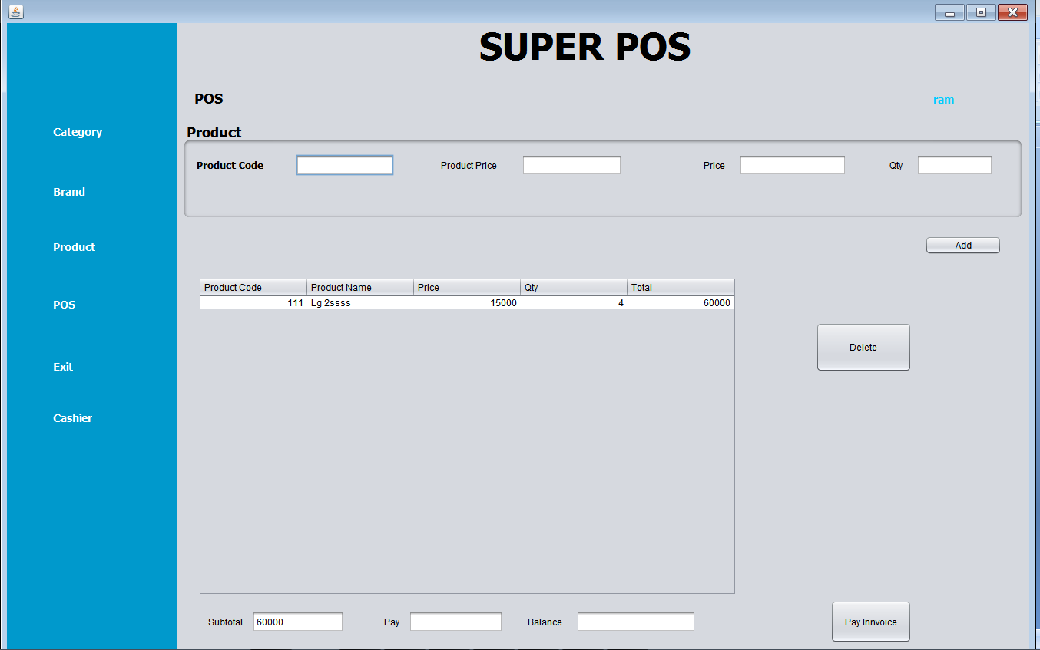(Display the complete detail stock details including product price and quantity based on the product code entered. It will calculate the total amount to be paid and also the amount returned to customer.)

CASHIER NAME

If the mentioned stock is not sufficient it will display message “Qty is not enough”.

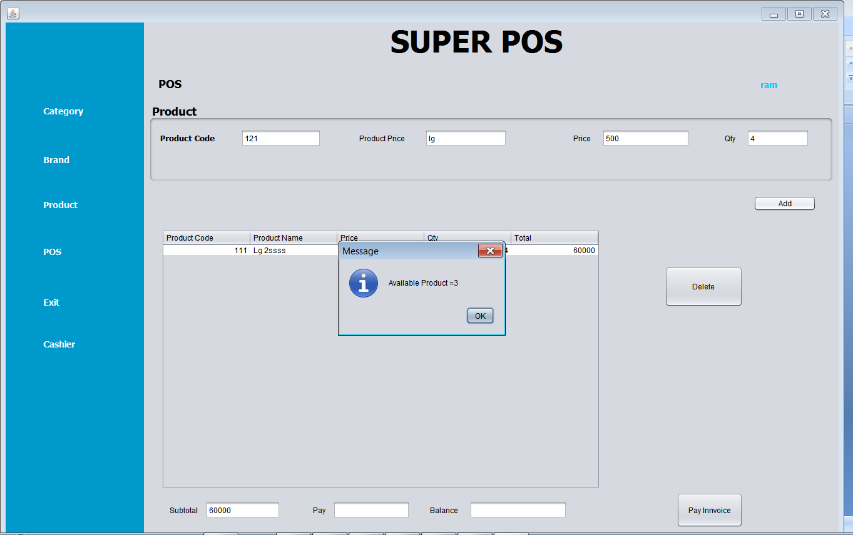

It will check quantity if it is not enough it will display the message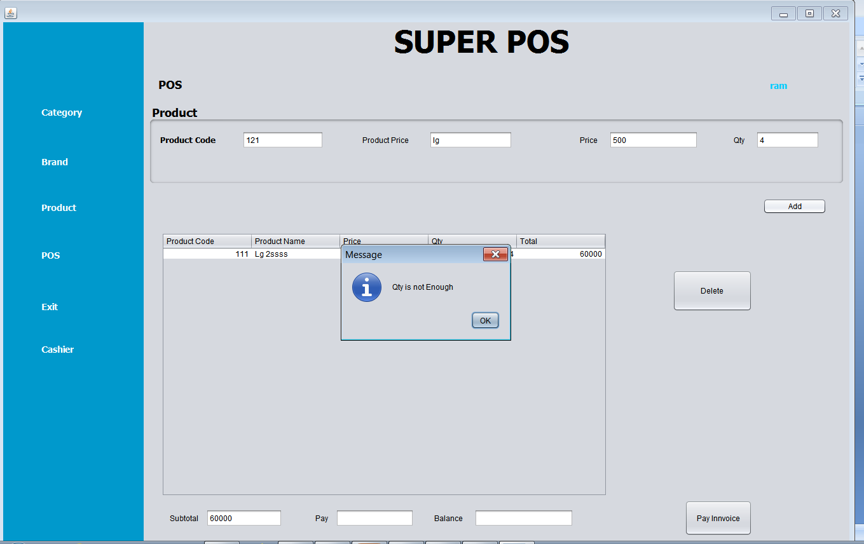

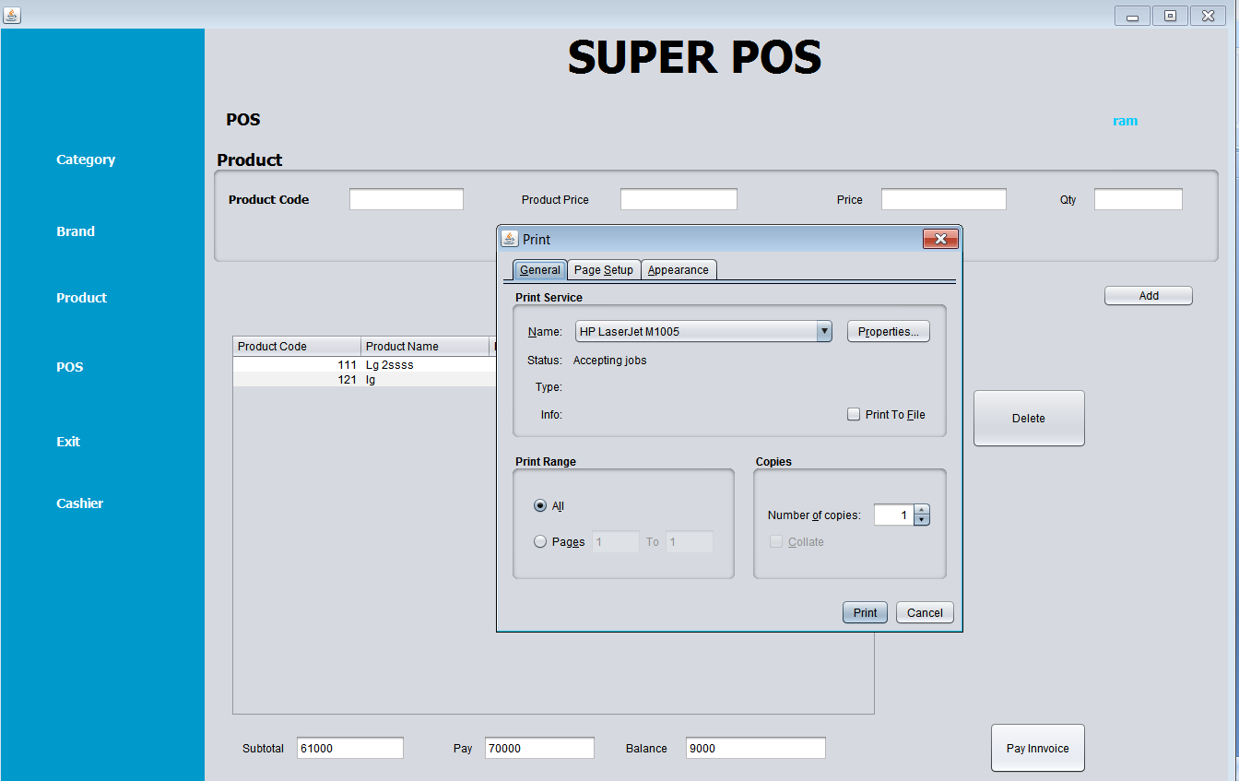

Add total amount of product by multiplying price and qty

Pay the amount as per it is required.

It will display balance amt returned

GENERATE BILL RECEIPT

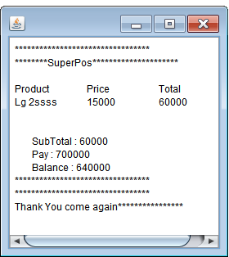

Brand Page

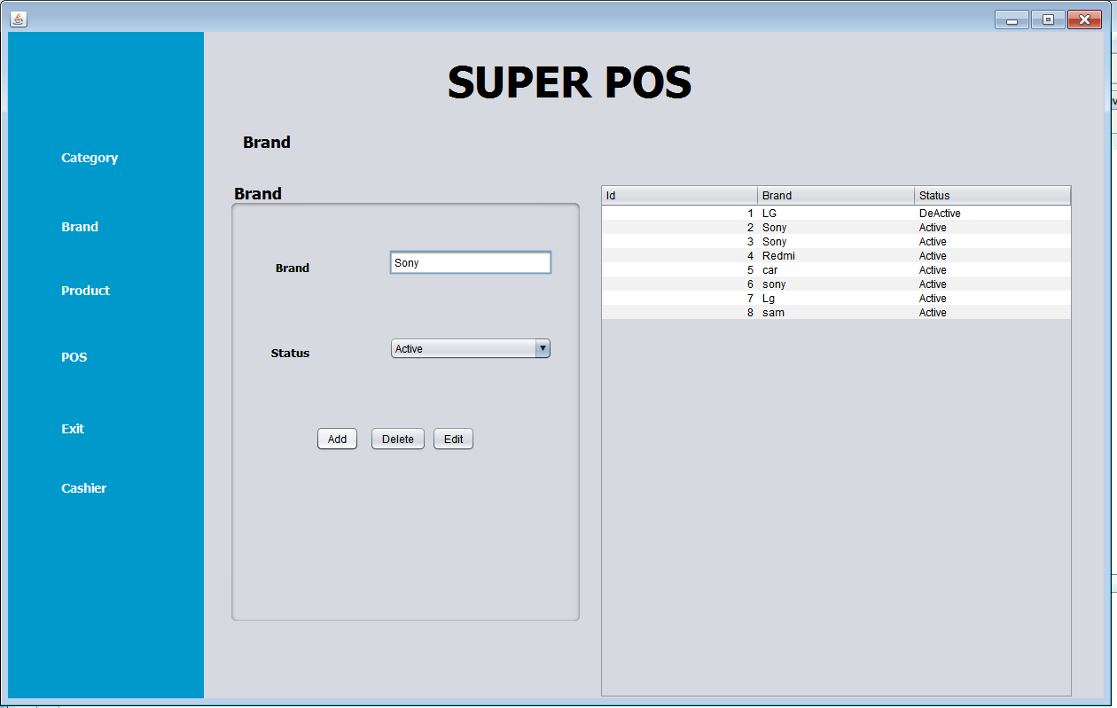

CATEGORY PAGE

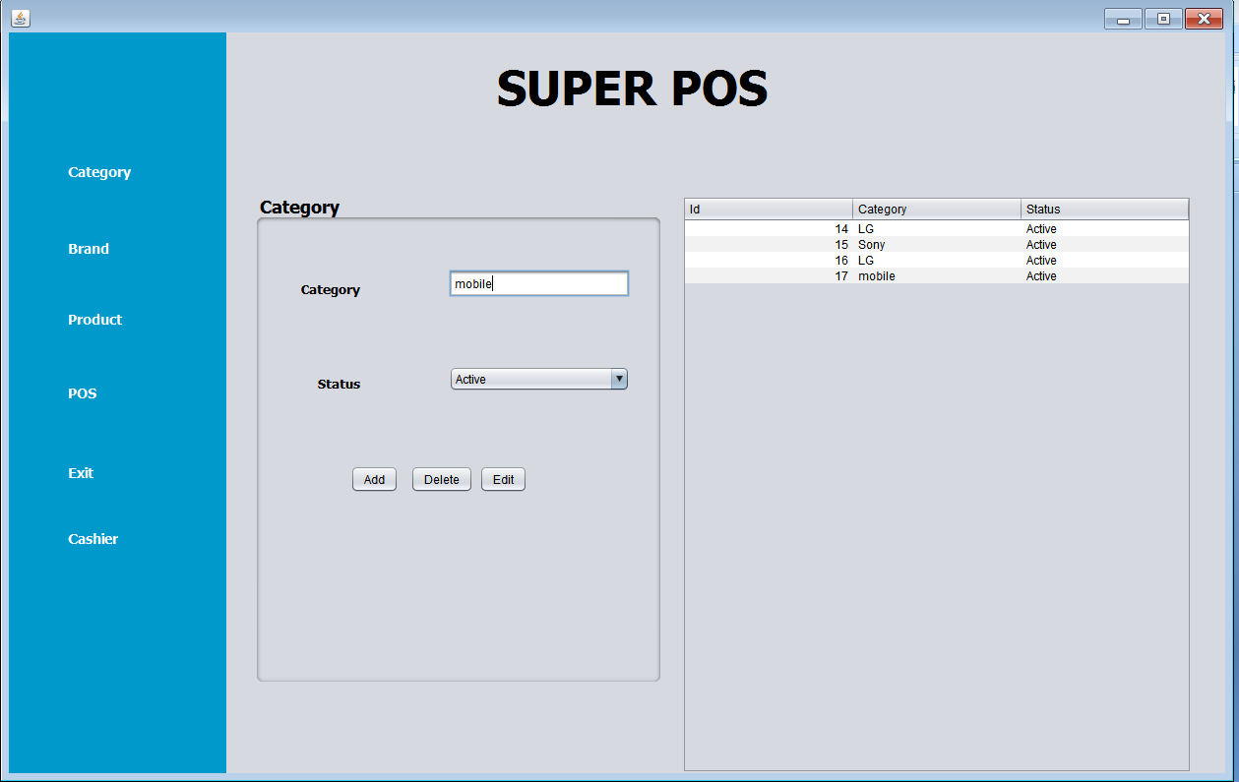

PRODUCT PAGE

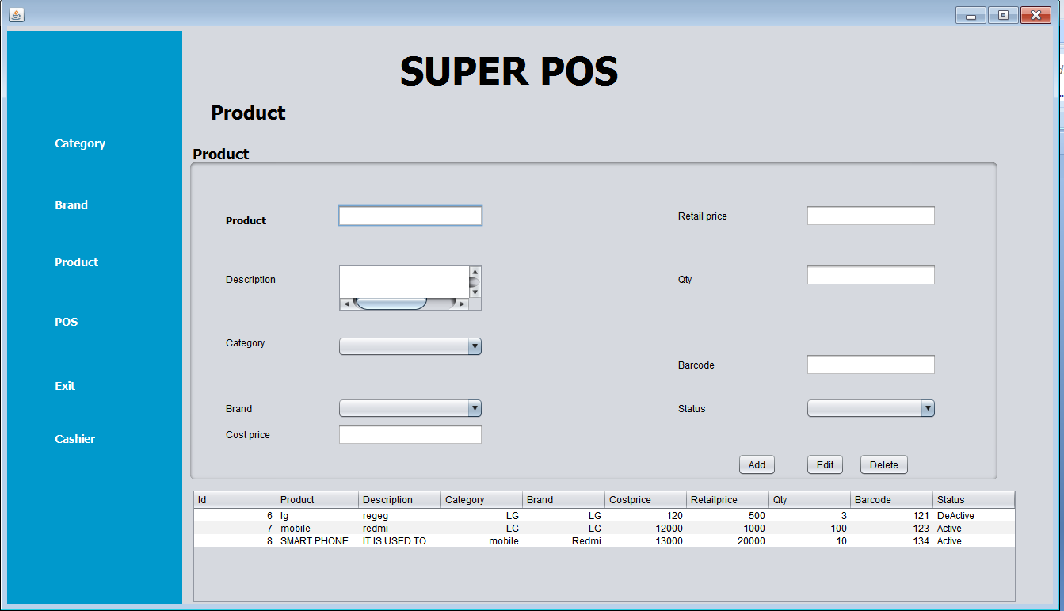

***DATABASE SCREENSHOTS(XAMPP SERVER)***

CASHIER DATABASE

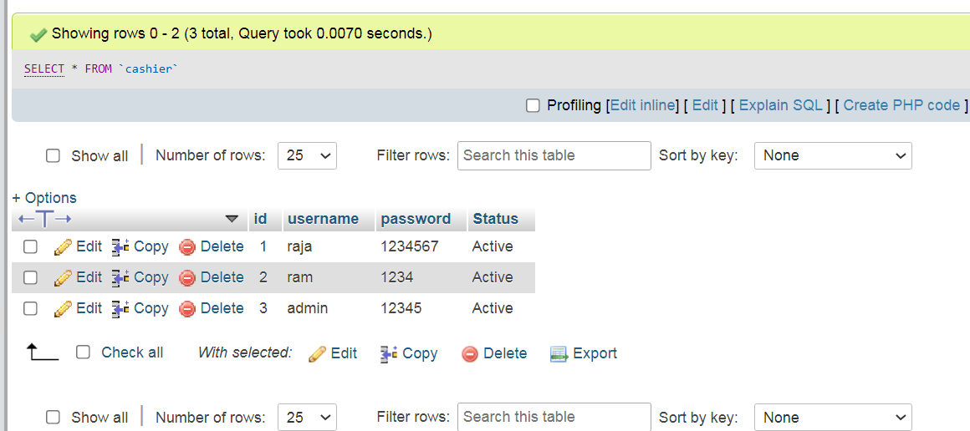

PRODUCT DATABASE

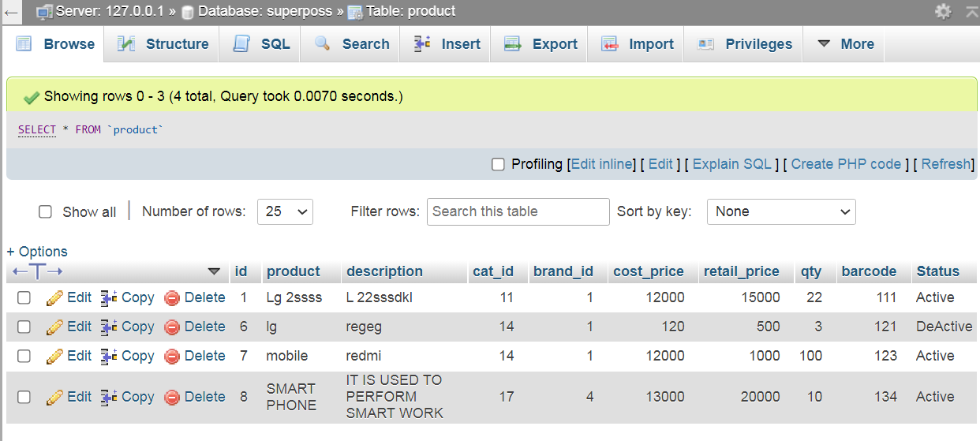

SALES DATABASE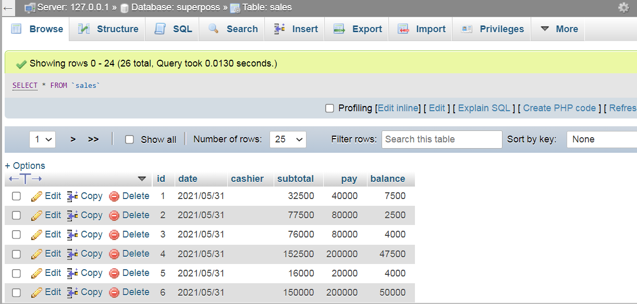

SALES_PRODUCT DATABASE

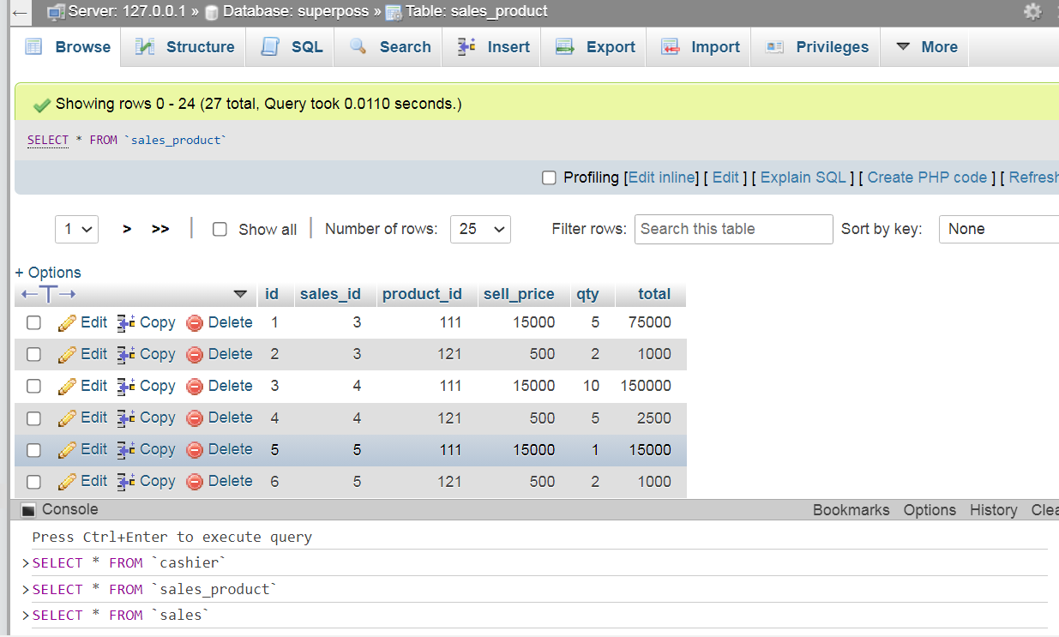

CATEGORY

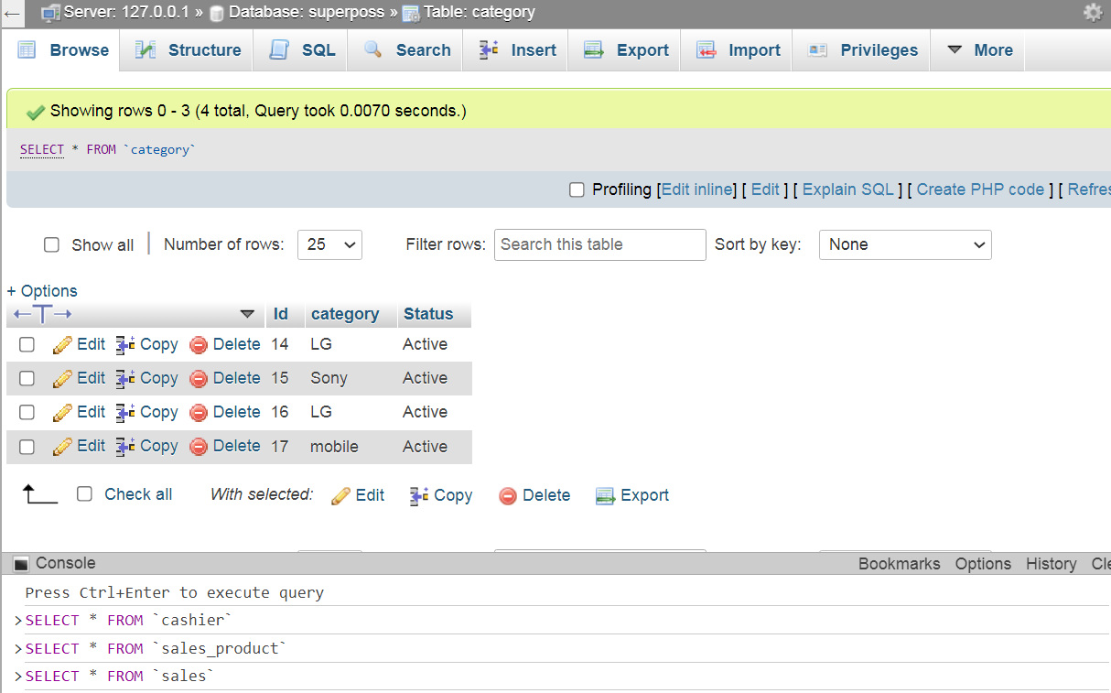

BRAND

